CHAPTER 12: Lesson 1
- Atmosphere is a mixture of gases that surrounds the earth.
- 78% nitrogen 21% oxygen 1% other
- Air pressure- is the measure of force with which the air molecules push on a surface.
- Altitude- height of an object above earth’s surface.
- Layers of the Atmosphere
- Troposphere
- lowest layer of the atmosphere
- densest layer
- Contains 90 % of Earth’s mass.
- All weather is in the troposphere.

- Stratosphere
- 2nd lowest layer of the atmosphere.
- Very thin air and contains little moisture
- Is extremely cold
- Ozone occurs here

- Mesosphere
- The coldest layer
- Large windstorms reaching to speeds more than 320 mph.

- Thermosphere
- Uppermost layer of the atmosphere
- Very high temperature but is not hot.
- Heat and temperature are not the same. Temp is a measure of the average energy of particles in motion. Heat is the transfer of energy between objects at different temperatures. In order for the troposphere to be hot heat molecules must touch to transfer heat, but they are too far apart to make heat.

- Ionosphere
- Layer in the upper mesosphere and the lower thermosphere.
- Nitrogen and oxygen absorb solar energy
- Causes gas molecules to be electrically charged called ions.
- Reflects radio waves

CHAPTER 12: Lesson 2
- Radiation is the transfer of energy as electromagnetic waves.
- 20% is absorbed by ozone, clouds, and atmospheric gases.
- 50% I absorbed by Earth’s surface
- 25% is scattered and reflected by clouds and air
- 5% is reflected by Earth’s surface.
- Conduction- transfer of thermal energy from one material to another by direct contact
- Convection- transfer of thermal energy by the movement of liquid or gas.
- Greenhouse effect- when gases in the atmosphere trap thermal energy
- Global warming- a rise in global temperatures

CHAPTER 12: Lesson 2&3
- Wind is the moving of air.
- Wind is created by differences in pressure
- Pressure belts- uneven heating of the earth which creates these belts of wind. These belts occur at about every 30 degrees of latitude.
- Coriolis Effect- Earth’s rotation causes wind to travel in a curved path rather than in a straight line.
- Northern hemisphere- winds curve to the right
- Southern Hemisphere- winds curve to the left
- LOCAL WINDS & GLOBAL WINDS
- Local winds- generally move short distances and can blow from any direction
- Global winds- are part of a pattern of air circulation that moves across the earth
- Trade Winds- In both hemispheres, these are the winds that blow from 30 degrees latitude to the equator
- The Doldrums- trade winds of northern and southern hemispheres meet in an area of low pressure around the equator. (Very little wind because of the warm air rising Doldrums means foolish, sailors was considered foolish if they got their ship stuck in these areas of little wind.
- Horse Latitudes- about 30 degrees north and south latitude, sinking air creates high pressure. Winds are weak, named this because sailors carried horses. When ships were stuck in an area due to lack of wind, horses were sometimes thrown overboard to save drinking water for the sailors.
- The Westerlies- are wind belts found in both the northern and southern hemispheres between 30 degrees and 60 degrees latitude. The westerlies flow toward the poles in opposite direction of the trade winds.
- Polar Easterlies- are wind belts that extend from the poles to 60 degrees latitude in both hemispheres. Polar easterlies are formed from cold, sinking air moving from the poles towards north and 60 degrees south latitude.
POLAR EASTERLIES

Horse Latitudes
60
WESTERLIES
30
Doldrums
TRADE WINDS

Horse Latitudes
TRADE WINDS

0
POLAR EASTERLIES
WESTERLIES
30
60
Jet Streams- are narrow belts of high-speed winds that blow in the upper troposphere and lower stratosphere.
LOCAL WINDS
SEA BREEZE:
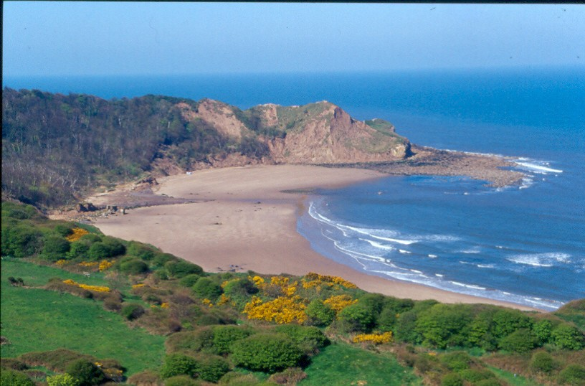
Air over the water is cooler and creates an area of air pressure.
As warm air rises, it creates an area of low pressure over the land.
Warm Air
Cool Air

The cool air moves toward the land, producing a sea breeze.

LAND BREEZE:
Air over the water is warmer and creates an area of low pressure.
The cool air moves toward the water, producing a land breeze.
Air over land is cooler and creates an area of high pressure

