VALLEY BREEZE:

MOUNTAIN BREEZE:

CHAPTER 1: Lesson 4
- Primary Pollutants- are pollutants that are put directly into the air by human or natural activity
  - Ex. Exhaust from cars, ash from volcanic eruptions, and soot from smoke.
- Secondary Pollutants- are pollutants that form from chemical reactions that occur when primary pollutants come in contacts with naturally occurring substances.
  - Ex. Water vapor
- Transportation is the main reason for pollution today
- Indoor Air pollution- examples; household cleaners, cooking smoke, new carpets, paints, and building materials.
- Acid Precipitation- precipitation that contains acids from air pollution
- Effects human health and can kill us.

CHAPTER 13: Lesson 1
- Weather- is the condition of the atmosphere at a particular time and place.
- The water cycle is the continuous movement of water from water sources, such as lakes and oceans, into the air, onto and over the land, into the ground, and back to the water sources.

WATER CYCLE:

- Condensation- occurs when water vapor cools and changes back into liquid droplets. This is how clouds are formed.
- Evaporation- occurs when liquid water changes into water vapor, which is gas and is absorbed by the clouds.
- Transpiration- is the process by which plants release water vapor into the air through their leaves.
- Precipitation- occurs when rain, snow, sleet, or hail falls from the clouds onto Earth’s surface.
- Run-off- is water, usually from precipitation, that flows across land and collects in rivers, streams, and eventually the ocean.
- -----------------------------------------------------------------------------------------------------
- Humidity- is the amount of water vapor or moisture in the air.
- Relative Humidity- is the amount of moisture the air contains compared to the maximum amount it can hold at a particular temperature.
- Condensation- is the process by which gas, such as water vapor, becomes liquid.
- Before this can happen, relative humidity must be 100 percent.
- Dew Point- is the temperature to which air must cool to be completely saturated.
CLOUDS
- Cloud- is a collection of millions of tiny water droplets or ice crystals.
- Forms as warm air rises and cools. As rising air cools, it becomes saturated
- Cumulus Clouds- puffy, high white clouds, with flat bottoms. Indicates fair weather.
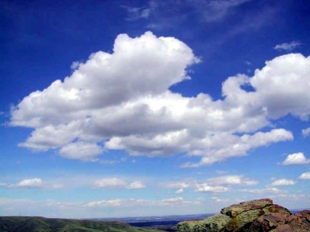
- Cumulonimbus Clouds- fluffy, dark a kind of cumulus cloud that produces thunderstorms.
**nimbus means precipitation**
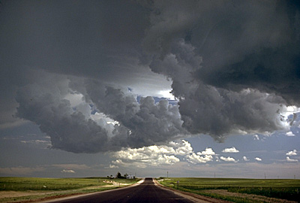

- Stratus Clouds- Clouds that form in layers, blanket/cover (low) covers entire area.
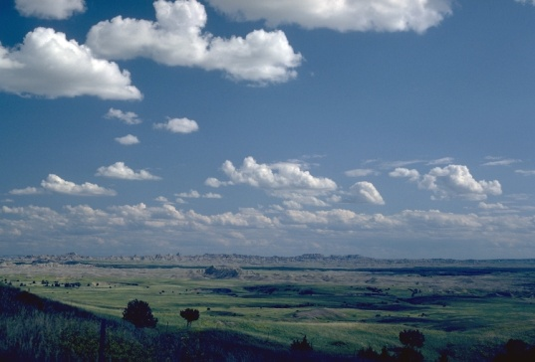
- Nimbostratus Clouds- dark blanket cloud that can produce light heavy, continuous rain.
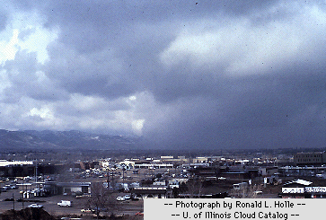
- Cirrus Clouds- thin, feathery, white clouds found at high altitudes. They form when wind is strong, and I they thicken that could indicate approaching bad weather. They are made out of ice crystals.
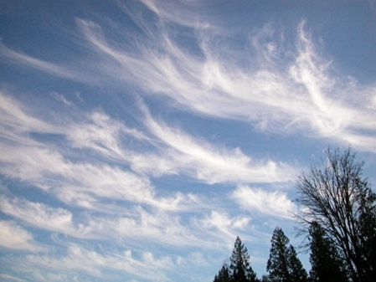
- Precipitation- is water, in solid or liquid form that falls from air to Earth.
- Snow- is the most common precipitation
- Sleet- is freezing rain
- Hail- Solid precipitation that falls as balls or lumps of ice
CHAPTER 13: Lesson 2
AIR MASSES
- Air mass- is a large body of air that has similar temperature characteristics from the area over which it forms.
- Cold air masses in the US- MP- forms in the North pacific, CP- forms in north Canada, MP- forms in Northern Atlantic
- Warm air masses in the US- MT- forms in south pacific, CT- forms over Mexico, MT- Gulf of Mexico, MT- over Southern Atlantic
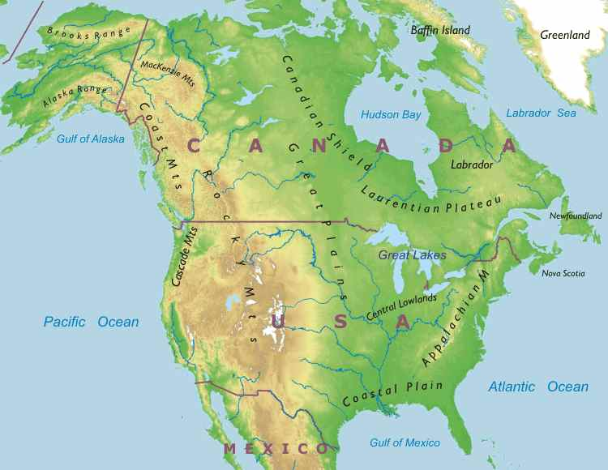

- Maritime (m) – forms over water; wet

- Continental (c) – forms over land; dry

- Polar (p)- forms over the polar regions; cold

- Tropical (t)- forms over the Tropics; warm

Fronts- Air masses with 2 different characteristics, such as temperature and humidity, do not usually mix. SO when 2 different air masses meet, a boundary is formed.

Cold Front- a cold air mass catches up to a warm air mass. *most likely causes storms*

Warm Front- warm air mass catches up and rides over a cold air mass

- Occluded Front- Warm gets trapped between 2 cold air masses.

- Stationary Front- (warm weather) when 2 fronts don’t move over each other.

CHAPTER 13: Lesson 2
Thunderstorms- are small, intense weather systems that produce strong winds, heavy rain, lightning, and thunder.
Lightning- is a large electrical discharge that occurs between 2 oppositely charged surfaces.
Thunder- is the sound that results from the rapid expansion of air along the lightning strike.
Tornado- is a small, rotating column of air that has high wind speeds and low pressure and touches the ground.
Hurricane- is a large rotating tropical storm weather system with wind speeds of at least 119 km. When hurricane travels over land it loses energy and begins to die down. Eye is the idle of the hurricane, around the eye is the eye wall, and the rain bands on the outside.

CHAPTER 13: Lesson 3

Thermometer- is a tool used to measure air temperature. (Liquid sealed in a glass tube. Alcohol, mercury)
Barometer- is an instrument used to measure air pressure. (Glass tube sealed at one end that is places in a container full of mercury)
Windsock or Wind vane- is used to measure wind direction.
Anemometer- is used to measure wind speed.
Tools
Weather balloons
Radar
Weather satellites
Isobars- are lines that connect points of equal air pressure rather than equal elevation on a map.
CHAPTER 3: SECTION 1
Weather- is the condition of the atmosphere at a particular time and place
Climate- the average weather condition in an area over a long period of time

OCEAN
LAND
RAIN SHADOW
DRY
^^Mountains block the prevailing winds from blowing across a continent, changing the amount of moisture the wind carries.

Latitude- is the distance north and south of the equator, measured in degrees.
Prevailing Winds- are winds that blow mainly from one direction.
Elevation- is the height of surface landforms above sea level.
Surface Currents- which can either be warm or cold, are stream like movements of water that occur at or near the surface of the ocean.
Things that Effect Climate
LATITUDE
PHYSICAL FEATURES
WINDS
OCEAN CURRENTS
SEASONS
POLLUTION- GLOBAL WARMING

