Astronomy chapter 4 test bank

Multiple Choice
Identify the letter of the choice that best completes the statement or answers the question.

____ 1. The majority of stars in our galaxy are
a. | blue. | c. | main-sequence stars.
b. | white dwarfs. | d. | red giants.

____ 2. Which would be seen as the brightest star in the following group?
a. | Alcyone—apparent magnitude of 3 | c. | Deneb—apparent magnitude of 1
b. | Alpheratz—apparent magnitude of 2 | d. | Rigel—apparent magnitude of 0

____ 3. A cluster of stars forms in a nebula. There are red stars, blue stars, yellow stars, and white stars. Which stars are most like the sun?
a. | red | c. | blue
b. | yellow | d. | white

____ 4. Individual stars are moving in space. How long will it take to see a noticeable difference without using a telescope?
a. | 24 hours | c. | 100 years
b. | 1 year | d. | 100,000 years

____ 5. You visited an observatory and looked through the telescope. You saw a ball of stars through the telescope. What type of object did you see?
a. | a spiral galaxy | c. | a globular cluster
b. | an open cluster | d. | an irregular galaxy

____ 6. In which part of a spiral galaxy do you expect to find nebulas?
a. | the spiral arms | c. | the halo
b. | the central region | d. | all parts of the galaxy

____ 7. Which statement about the big bang theory is accurate?
a. | The universe will never end.
b. | New matter is being continuously created in the universe.
c. | The universe is filled with radiation coming from all directions in space.
d. | We can locate the center of the universe.

____ 8. Which of the following magnitudes indicates the brightest star?
a. | –1 | c. | –0.11
b. | 0 | d. | +4

____ 9. Which of the following is the largest?
a. | a nebula | c. | a neutron star
b. | a galaxy | d. | a globular cluster

____ 10. The parallax method can be used to determine the distance of a star from Earth. However, the parallax method loses accuracy if the star is too
a. | hot. | c. | large.
b. | far away. | d. | bright.

____ 11. Which of the following is the hottest?
a. | a red supergiant star | c. | a main-sequence yellow star
b. | a small black-dwarf star | d. | a main-sequence blue star

____ 12. According to the big bang theory, the universe is about
a. | 470 billion years old. | c. | 4.7 billion years old.
b. | 500 billion years old. | d. | 15 billion years old.

____ 13. A star's apparent magnitude is dependent on
a. | its distance from Earth. | c. | its size.
b. | its energy output. | d. | All of the above

____ 14. Which flame color burns the hottest?
a. | red | c. | yellow
b. | orange | d. | blue

____ 15. Which flame color burns the coolest?
a. | red | c. | yellow
b. | orange | d. | blue

____ 16. If two stars are different colors, we can infer that they have different
a. | masses. | c. | temperatures.
b. | shapes. | d. | chemical compositions.

____ 17. When you look at white light through a glass prism, you see a rainbow of colors called
a. | parallax. | c. | an apparent magnitude.
b. | a spectrum. | d. | an absolute magnitude.

____ 18. Which spectrum is given off by a glowing wire inside a light bulb?
a. | absorption spectrum | c. | continuous spectrum
b. | reflection spectrum | d. | diffusion spectrum

____ 19. Stars are not solid, so what is the surface of a star?
a. | the part that we see
b. | the part so dense it acts like a hot solid
c. | the part that emits a continuous spectrum
d. | all of the above

____ 20. Which statement best describes why a star's spectrum contains various dark lines in it?
a. | The stars only give off emission lines, not a continuous spectrum.
b. | The light passes through cooler gases that absorb some wavelengths.
c. | Both the surface and the atmosphere of a star are the same temperature.
d. | all of the above

____ 21. We can infer that when dark bands that match the wavelengths of hydrogen's emission lines appear in an absorption spectrum, hydrogen is
a. | not present in the star. | c. | the cooler gas absorbing the light.
b. | present in the core. | d. | All of the above

____ 22. If light from a hot solid passes through a cooler gas, it produces a(n) ____ spectrum.
a. | transmission | c. | absorption
b. | emission | d. | continuous

____ 23. Stars are now classified by their
a. | chemical composition. | c. | distance from Earth.
b. | temperature. | d. | mass.

Examine the table below and answer the questions that follow.
Types of Stars
Class | Color | Surface temperature (°C) | Elements detected
O | blue | above 30,000 | helium
B | blue-white | 10,000–30,000 | helium and hydrogen
A | blue-white | 7,500–10,000 | hydrogen
F | yellow-white | 6,000–7,500 | hydrogen and heavier elements
G | yellow | 5,000–6,000 | calcium and other metals
K | orange | 3,500–5,000 | calcium and molecules
M | red | less than 3,500 | molecules

____ 24. The stars Betelgeuse and Antares are red in color. They are class ____ stars.
a. | O | c. | K
b. | G | d. | M

____ 25. The absorption spectrum of Sirius shows that it contains only hydrogen. Sirius is a class ____ star.
a. | A | c. | G
b. | O | d. | M

____ 26. An example of a class O star is 10 Lacertae. What is its chemical composition?
a. | helium | c. | hydrogen
b. | helium and hydrogen | d. | calcium and other metals

____ 27. Our sun is a yellow star. In what temperature range does it burn?
a. | less than 3,500°C | c. | 5,000–6,000°C
b. | 3,500–5,000°C | d. | 6,000–7,500°C

____ 28. Our sun is a class ____ star.
a. | A | c. | G
b. | B | d. | O

____ 29. Our sun is yellow. What elements have been detected in our sun?
a. | helium | c. | hydrogen and heavier elements
b. | calcium and other metals | d. | hydrogen

Examine the illustration indicating the relative brightness of the stars in the Big Dipper constellation, and answer the questions that follow.
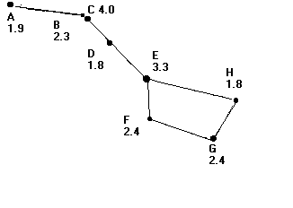

____ 30. Which star is the least bright?
a. | A | c. | C
b. | B | d. | D

____ 31. Which stars are the brightest?
a. | A and F | c. | D and H
b. | C and F | d. | C and E

____ 32. How bright a light looks is called
a. | relative brightness. | c. | absolute magnitude.
b. | apparent magnitude. | d. | parallax.

Suppose you are walking along a street after sunset in a heavy snowfall. You know that the next street lamp is 10 m away. You also know that this particular city spaces their street lamps 10 m apart.

____ 33. From where you are standing, the light that is 10 m away will appear ____ times as bright as one that is 20 m away.
a. | two | c. | six
b. | four | d. | nine

____ 34. From where you are standing, the light that is 10 m away will appear ____ times as bright as one that is 30 m away.
a. | two | c. | six
b. | four | d. | nine

____ 35. You can estimate how far away each street light is by looking at its
a. | relative brightness. | c. | apparent magnitude.
b. | absolute magnitude. | d. | parallax.

____ 36. The actual brightness of a star is called its
a. | relative brightness. | c. | absolute magnitude.
b. | apparent magnitude. | d. | parallax.

____ 37. ____ occurs when stars near Earth appear to move when compared with more-distant stars as Earth revolves around the sun.
a. | Relative brightness | c. | Absolute magnitude
b. | Apparent magnitude | d. | Parallax

Examine the diagram below, and answer the questions that follow.
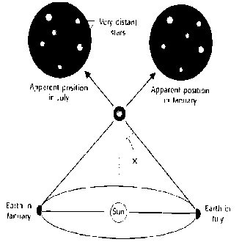

____ 38. In the diagram above, X indicates
a. | the absolute magnitude of the star. | c. | parallax.
b. | the apparent magnitude of the star. | d. | the star's distance from the sun

____ 39. The diagram above shows that the
a. | apparent position of the background stars change relative to the observed star.
b. | distance to the observed star can be calculated even though Earth is far away.
c. | Earth's change in position throughout the year enables a star's distance to be calculated.
d. | All of the above

____ 40. The H-R diagram has become a tool for studying the nature of stars because it shows how stars
a. | are classified by temperature. | c. | change over time.
b. | are classified by brightness. | d. | All of the above

____ 41. Stars similar to the sun are called
a. | white dwarfs. | c. | red dwarfs.
b. | dwarfs. | d. | red giants.

____ 42. Our sun has an absolute magnitude of +5. Compare this with a star that has an absolute magnitude of –7. The sun is ____ the –7 star.
a. | brighter than | c. | the same brightness as
b. | not as bright as | d. | larger than

____ 43. When our sun runs out of hydrogen in its core, its center will shrink inward and the outer parts will expand outward. The atmosphere will grow very large and cool, and the sun will become a
a. | white dwarf. | c. | red giant.
b. | red dwarf. | d. | supergiant.

____ 44. When a massive star much larger than our sun runs out of hydrogen in its core, the center of the star shrinks inward and the outer parts expand outward. The atmosphere grows very large and cool, and the star becomes a
a. | white dwarf. | c. | red giant.
b. | red dwarf. | d. | supergiant.

____ 45. ____ are low-mass stars that remain on the main sequence a long time and may be some of the oldest stars in the galaxy.
a. | White dwarfs | c. | Red giants
b. | Red dwarfs | d. | Supergiants

____ 46. The star Naos is very massive and will not remain in the main sequence very long. It will quickly use up the hydrogen in its core, expand, and turn into a giant, supergiant, or even end its life in a supernova. Naos is an example of a
a. | blue star. | c. | red dwarf.
b. | white dwarf. | d. | dwarf.

Examine the illustrations of galaxies below, and answer the questions that follow.
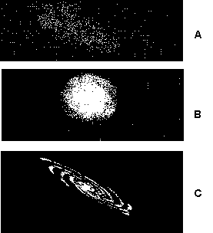

____ 47. Illustration A is a(n)
a. | spiral galaxy. | c. | irregular galaxy.
b. | elliptical galaxy | d. | quasar.

____ 48. Illustration B is a(n)
a. | spiral galaxy. | c. | irregular galaxy.
b. | elliptical galaxy | d. | quasar.

____ 49. Illustration C is a(n)
a. | spiral galaxy. | c. | irregular galaxy.
b. | elliptical galaxy. | d. | quasar.

____ 50. In space, ____ are giant clouds of gas and dust.
a. | nebulas (or nebulae) | c. | open clusters
b. | globular clusters | d. | quasars

____ 51. ____ are groups of older stars that appear as a ball of stars near spiral and giant elliptical galaxies.
a. | Open clusters | c. | Nebulas (or nebulae)
b. | Globular clusters | d. | Quasars

____ 52. ____ are groups of stars that are usually located along the spiral disk of a galaxy.
a. | Nebulas (or nebulae) | c. | Open clusters
b. | Globular clusters | d. | Quasars

____ 53. Among the most distant objects are ____, which are among the most powerful energy sources in the universe.
a. | nebulas (or nebulae) | c. | open clusters
b. | globular clusters | d. | quasars

____ 54. If you see a quasar that is 6 billion light-years away, you are seeing light that
a. | is being emitted as you observe. | c. | was emitted an hour ago.
b. | was emitted 10 minutes ago. | d. | was emitted 6 billion years ago.

____ 55. According to the big bang theory, all contents of the universe were gathered together under extreme ____ in a very tiny spot.
a. | pressure | c. | density
b. | temperature | d. | All of the above

____ 56. According to the big bang theory, how did matter form?
a. | The expanding energy became matter.
b. | The contracting energy became matter.
c. | Matter formed only after life existed.
d. | Interstellar gas and dust formed matter.

____ 57. According to the big bang theory, ____ from the original explosion was distributed in every direction as the universe expanded.
a. | water | c. | thermal energy
b. | meteorites | d. | hydrogen

____ 58. Which of the following statements supports the big bang theory?
a. | All galaxies move away from each other.
b. | Cosmic background radiation fills all of space.
c. | Energy can turn into matter.
d. | all of the above

____ 59. One way astronomers can measure the age of the universe is by measuring
a. | the rate of universal expansion. | c. | cosmic background radiation.
b. | the distance to the farthest galaxies. | d. | the age of our sun.

____ 60. Why can astronomers use the speed of light to calculate distances?
a. | Light travels at the same speed in empty space.
b. | Light speed increases at the same rate as the universe increases in size.
c. | Light slows down only when it stops to land on Earth.
d. | all of the above

____ 61. A star is most likely born in a
a. | globular cluster. | c. | black hole.
b. | nebula. | d. | giant cluster of old stars.

____ 62. How does a star die?
a. | in a supernova explosion | c. | when it enters a spiral galaxy
b. | in a globular cluster | d. | always in a nebula

____ 63. Which of the following could be formed as a result of a supernova?
a. | a black hole | c. | a pulsar
b. | a neutron star | d. | all of the above

____ 64. Which star would most likely be the oldest?
a. | a blue star | c. | a red giant
b. | a blue-white star | d. | our sun

____ 65. Which star would most likely be the youngest?
a. | a blue star | c. | a red giant
b. | a white dwarf | d. | a red dwarf

____ 66. Cosmology is the study of
a. | the life cycle of stars. | c. | the origin and future of the universe.
b. | the location of stars. | d. | how solar systems form.

____ 67. A ____ forms when the leftovers of a supernova are so massive that they collapse to form a dense object with gravity so strong that light cannot escape it.
a. | black hole | c. | quasar
b. | red giant | d. | pulsar

Completion
Complete each sentence or statement.

68. A star's ____________________ magnitude does not depend on its distance form Earth. (apparent or absolute)

69. The study of the formation of the universe is called ____________________. (the big bang theory or cosmology)

70. Our sun is located in the arm of a pinwheel-shaped ____________________ galaxy in the Milky Way. (spiral or elliptical)

71. A ____________________ is so small and massive that not even light can escape its gravitational pull. (black hole or neutron star)

72. Elliptical galaxies and the halos of spiral galaxies contain groups of stars called _________________________. (globular clusters or supernovas)

73. Astronomers use an instrument called a _________________________ to spread starlight out into its colors, just as you might use a prism to spread sunlight.

74. Bright lines that are made when certain wavelengths of light are given off by hot gases are called ___________________ lines.

75. A ____________________ is the distance that light travels in one year.

Suppose you look through a telescope in July and then again in January. Below is a picture of what you see each time. Examine the pictures below and answer the questions that follow.
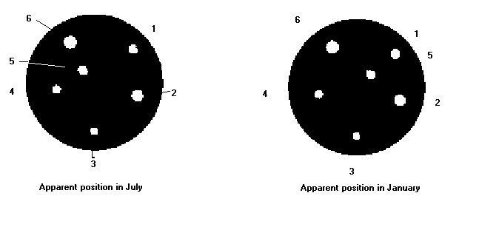

76. Star ____________________ appeared to change position from July to January.

77. Stars ____________________ did NOT appear to change position from July to January.

78. Star ____________________ is closest to Earth.

79. Stars ____________________ are very distant stars from Earth.

80. The star did NOT really move, so the movement of the star is an ____________________ motion.

81. The movement of the ____________________ is an actual motion and caused the apparent movement of the star.

82. The ____________________ is a graph showing the relationship between a star's surface temperature and its absolute magnitude.

83. The movement of the sun across the sky is an ____________________ motion.

84. The diagonal pattern of stars on the H-R diagram is called the _________________________.

85. A ____________________ is basically the death of a large star by explosion.

86. A ____________________ star is a dense star that is formed when the leftover materials in the center of a supernova are squeezed together so that the particles inside the star become neutrons.

87. A ____________________ is a spinning neutron star.

88. ____________________ are large groupings of stars in space.

89. ____________________ galaxies have a bulge at the center and very distinctive spiral arms.

90. ____________________ galaxies have very bright centers and very little dust and gas.

91. ____________________ galaxies do not fit into any other class of galaxy.

92. The _________________________ states that the universe began with a tremendous explosion.

93. Evidence that supports the big bang theory is the _________________________ radiation that fills all of space.

Short Answer

For each pair of terms, explain the difference in their meanings.

94. big bang/cosmic background radiation

95. elliptical galaxy/spiral galaxy

96. white dwarf/black hole

97. main-sequence star/red giant

98. spectrum/parallax

99. absolute magnitude/apparent magnitude

100. Is a yellow star, such as the sun, hotter or cooler than an orange star? Explain.

101. Suppose you see two stars that have the same apparent magnitude. If one star is actually four times as far away as the other, how much brighter would the farthest star really be?

102. Are blue stars young or old? How can you tell?

103. In main-sequence stars, what is the relationship between brightness and temperature?

104. Arrange the following in order of their appearance in the life cycle of a star: white dwarf, red giant, main-sequence star. Explain your answer.

105. Given that there are more low-mass stars than high-mass stars in the universe, do you think in the future there will be more white dwarfs or more black holes? Explain.

106. Arrange these galaxies in order of decreasing size: spiral, giant elliptical, dwarf elliptical, irregular.

107. Describe the difference between an elliptical galaxy and a globular cluster.

108. Suppose a quasar suddenly underwent some dramatic change. How long would we have to wait to see this change? Explain.

109. Name one observation that supports the big bang theory.

110. How does the big bang theory explain the observed expansion of the universe?

111. Large telescopes gather more light than small telescopes gather. Why are large telescopes used to study very distant galaxies?

112. How does apparent magnitude differ from absolute magnitude?

113. What is parallax?

114. How is the distance from Earth to a star measured?

115. How is the apparent movement of the stars in the night sky different from the movement of the stars within a constellation?

116. What information does the H-R diagram give us?

117. What is a supernova?

118. a. What is a neutron star?
b. How does it differ from a pulsar?

119. What is a nebula?

120. What are open clusters?

121. Why is looking through a telescope at a distance galaxy like looking back in time?

122. What is cosmic background radiation?

123. How is the structure of the universe repeated?

124. Describe how the apparent magnitude of a star varies with its distance from Earth.

125. Name six types of astronomical objects in the universe. Arrange them by size.

126. Which contains more stars on average, a globular cluster or an open cluster?

127. What does the big bang theory have to say about how the universe will end?

128. Use the following terms to create a concept map: black hole, neutron star, main-sequence star, red giant, nebula, white dwarf.

129. If a certain star displayed a large parallax, what could you say about its distance from Earth?

130. Two M-type stars have the same apparent magnitude. Their spectra show that one is a red giant and the other is a red-dwarf star. Which one is farther from Earth? Explain your answer.

131. a. Why do astronomers use absolute magnitudes to plot the stars?
b. Why don’t they use apparent magnitudes?

132. While looking at a galaxy through a nearby university’s telescope, you notice that there are no blue stars present. What kind of galaxy is it most likely to be?

133. An astronomer observes two stars of about the same temperature and size. Alpha Centauri B is about 4 light-years away, and sigma2 Eridani A is about 16 light-years away. How much brighter does Alpha Centauri B appear?

The following graph illustrates the Hubble law relating the distances of galaxies and their speed away from us.
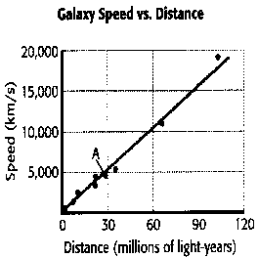

134. Look at the galaxy marked A in the graph. What is its speed and distance?

135. If a new galaxy with a speed of 15,000 km/s were found, at what distance would you expect it to be?

136. Describe the three types of galaxies originally identified by Edwin Hubble.

137. How can astronomers find out which elements are in a particular star?

138. The sun is about 1.5 × 10¹¹ m from Earth. If the sun suddenly went out, about how many minutes would elapse before people on Earth would know?
(Hint: The speed of light is about 3 × 10⁸ m/s.) Show your work.

139. If you traced the paths of the stars in the night sky over a few hours, they would all appear to circle around the North Star. Why?

Analyze this H-R diagram and complete the items that follow.
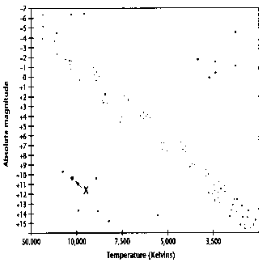

140. Describe the temperature and brightness of the star marked with an X.

141. Outline the approximate area of main-sequence stars on the diagram.

142. Use the following terms to complete the concept map below: nebulas, supernovas, galaxy clusters, globular clusters, galaxies, planets, stars.

